
YOU ARE INVITED TO PACK _________
GET OUT & CUB SCOUT SIGN-UP MEETING!

Our pack would like you to attend our upcoming meeting to sign-up for Cub Scouts. We are planning to HAVE SOME FUN and GET OUT & CUB SCOUT this fall and would like your family to join us! Here are the details for our upcoming sign-up:

Where: ____________________________
When: _______________________

Fees associated with joining and/or rejoining will be shared at the meeting.

Our sign-up meeting will be an opportunity for us to reengage/invite any interested previous members and offer the opportunity to introduce potential new members to Cub Scouts.

Forward this email to a friend or family member that may be interested in attending our meeting with you!
Watch this video and see all the fun we’re having in Cub Scouts.

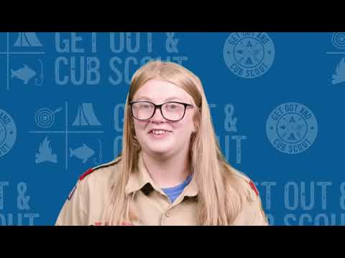

We plan to share additional information about our pack, along with information on upcoming activities and have some fun at the meeting. Please join us! For more information, please contact
__________________________________________.

